**HADIAH PRAKTEK PBO PERT 9**

1. Hadiah 1

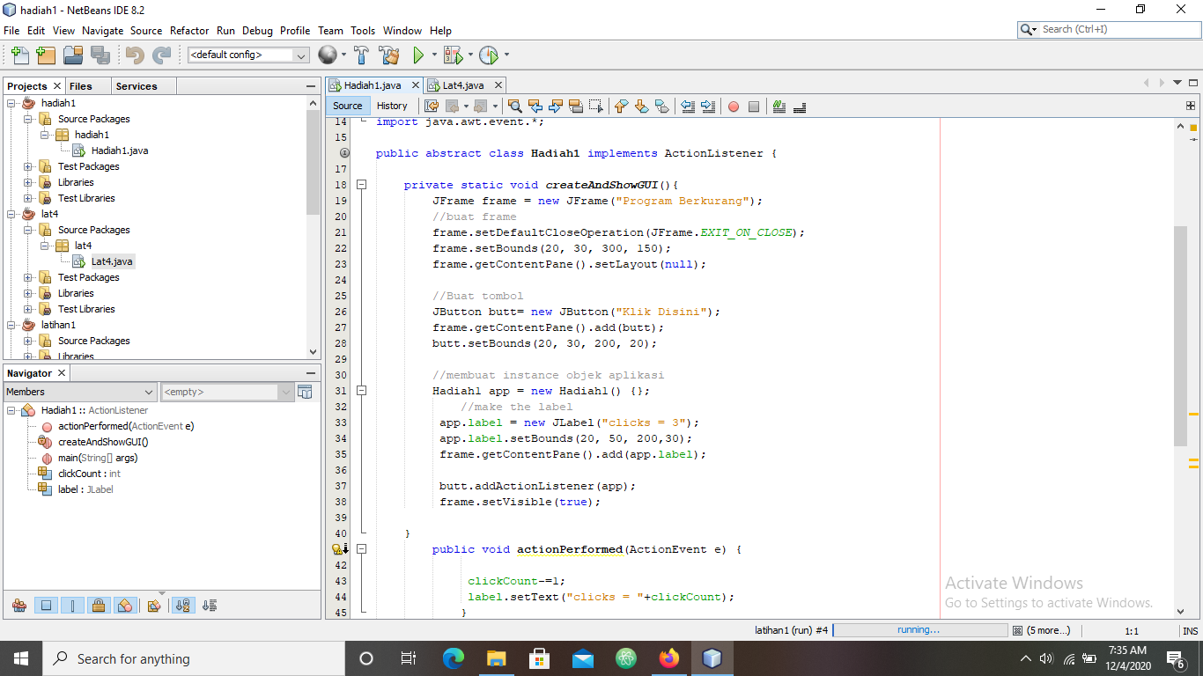

**Hasil Run Hadiah 1**

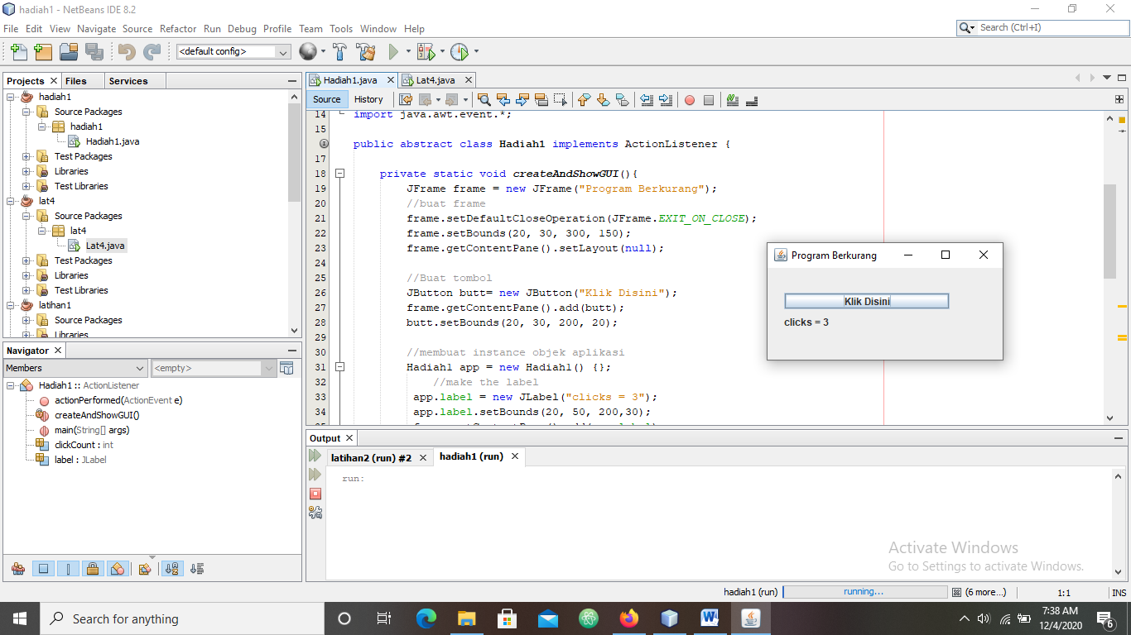

1. Hadiah 2

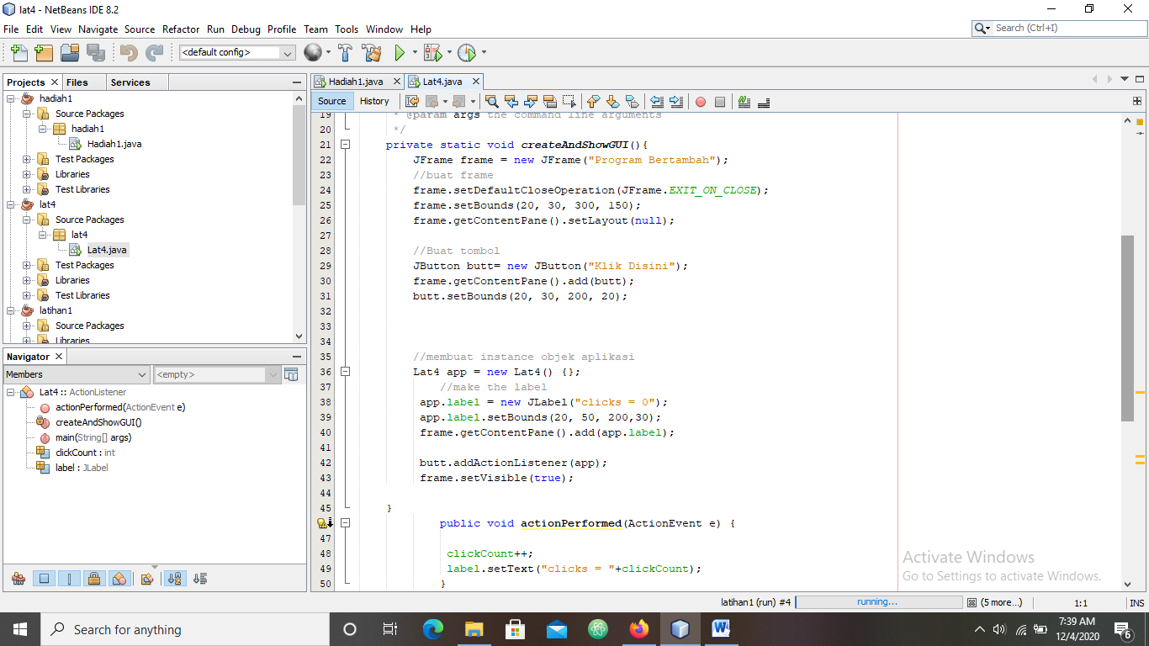

**Hasil Run Hadiah 2**

